**Case Study 1**:

Create a class Employee and derive a child class programmer using public inheritance.

• Create class case diagram.

• Code the parent and derive classes on python

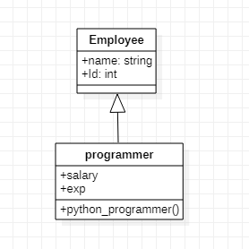

#case study 1

class Employee:

def __init__(self,name,id):

self.name=name

self.id=id

class Programmer(Employee):

def __init__(self,name,id):

super().__init__(name,id)

def Python_programmer(self):

return(self.name,self.id)

p=Programmer("Huzaifa","021")

print(p.Python_programmer())

C:\Users\HASSAN ENTERPRISES\Desktop\oop lab 6 semester 2 pic 1.png

**Case Study 2**

Create a parent class Employee, derive child class Programmer and Designer using inheritance

• Create class case diagram.

• Code the parent and derive classes on python

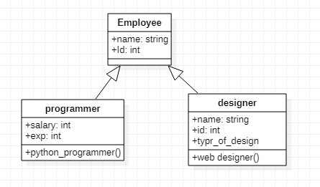

#case study 2

class Employee:

def __init__(self,name,age):

self.name=name

self.age=age

def Detail(self):

return("Employee Data Name age and post is ",self.name,self.age)

class programmer:#yahan pr programmer ek dusarii class haii joo inherit haii upper walii class say likin

#eska oject ki help say may nay upper wali class ka attributes koo call kiyaaa

def __init__(self,salary,prolang,exp):

self.salary=salary

self.prolang=prolang

self.experience=exp

def Details(self):

return(self.salary,self.prolang,self.experience)

class Designer(Employee,programmer):

def __init__(self,name,age,salary,prolang,exp):

Employee.__init__(self,name,age)

programmer.__init__(self,salary,prolang,exp)

D=Designer("Muhammad",20,440000,"python","5-Year")

print(D.Details())

print(D.Detail())

C:\Users\HASSAN ENTERPRISES\Desktop\oop lab 6 semester 2 pic 2.png

**Case Study 3**:

Analyze the detail system of car loan management system. You can take help of internet to find you any car loan management system. Your task is as follows:

b. Define all the existing processes in loan management system.

c. Create classes.

d. Create use case diagram.

e. Make activity and sequence diagram.

f. Now select any class and try to enhance it according to your gap analysis.

g. Code the class for which you have enhance the process.

#case study 3

class Bank:

def __init__(self,bank_location,bank_Name,bank_code,bank_local_currency,bank_discount_currency):

self.bank_location=bank_location

self.bank_Name=bank_Name

self.bank_code=bank_code

self.bank_local_currency=bank_local_currency

self.bank_discount_currency=bank_discount_currency

def Bank_detailed(self):

return(f"The name of the Bank is {self.bank_Name} near {self.bank_location}. Bank code is {self.bank_code} .Bank Local currency is {self.bank_local_currency} \n discount currency is {self.bank_discount_currency}")

class Account(Bank):

def __init__(self,bank_location,bank_Name,bank_code,bank_local_currency,bank_discount_currency):

Bank.__init__(self,bank_location,bank_Name,bank_code,bank_local_currency,bank_discount_currency)

class Banker(Account):

def __init__(self,bank_location,bank_Name,bank_code,bank_local_currency,bank_discount_currency,Name):

Account.__init__(self,bank_location,bank_Name,bank_code,bank_local_currency,bank_discount_currency)

self.Name=Name

def ManagerDetail(self):

return(f"Hello Sir my name is {self.Name}")

print("How can I help you sir? I deals All the customer those need loans if you can by a loan told me your account details")

def verification(self,customer_detail,customer_Name,customerAccount_Number,x,loan):

self.x=x

self.customer_detail=customer_detail

self.customer_Name=customer_Name

self.customerAccount_Number=customerAccount_Number

self.loan=loan

if(self.x=="yes"):

print(f"The User name is {self.customer_Name}\n The User Account number is {self.customerAccount_Number}\n And Its Detail are {self.customer_detail} .\n After Checking your previous record Bank give A loan of Rs={self.loan}")

else :

print("sir Kindy open your accounr First then I would give a loan")

x=input("Do you have an account Sir please reply in yes/no ")

customer_Name=input("Please tell me your name Sir")

customerAccount_Number=input("Please tell me your Account Number")

loan=input("How many loan you want to buy")

ba=Banker("Near Nazimabad","HBL Limited","#2768","pk","######","Bilal")

print(ba.Bank_detailed())

print(ba.ManagerDetail())

print(ba.verification(["BankBalance of your account is Rs=340000"],UserAccount_Name,UserAccount_Number,x,loan))

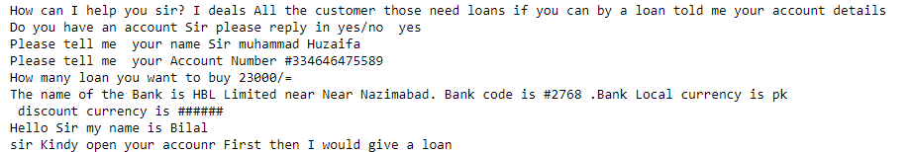

Car Loan Management System

CLASS DIAGRAM:

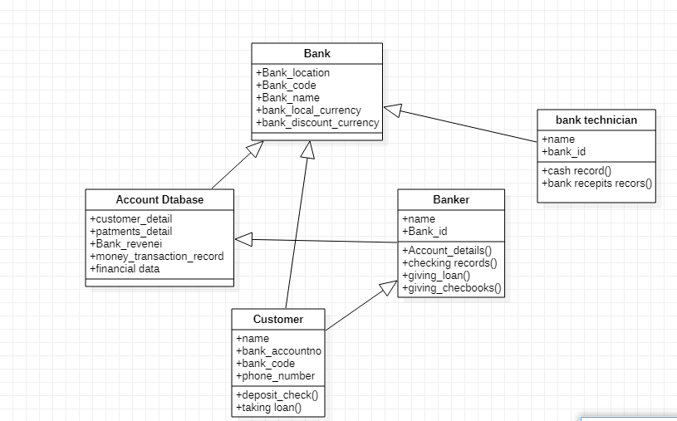

USECASE DIAGRAM :

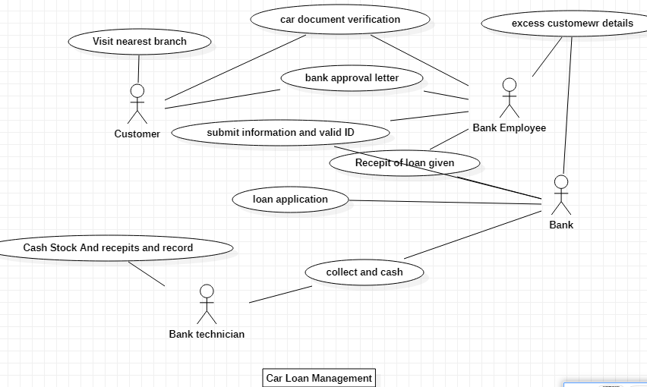

SEQUENCE DIAGRAM :

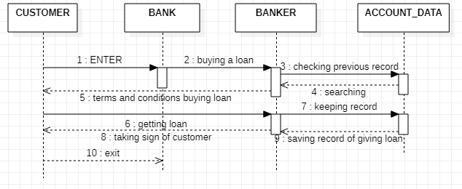

Analyze the detail system of Cargo Management System. You can take help of internet to find you any cargo management system. Your task is as follows:

a. Define all the existing processes in cargo management system.

b. Create the main classes.

c. Create use case diagram.

d. Make activity and sequence diagram.

e. Now select any class and try to enhance it according to your gap analysis.

f. Code the class for which you have enhance the process.

CLASS DIAGRAM:

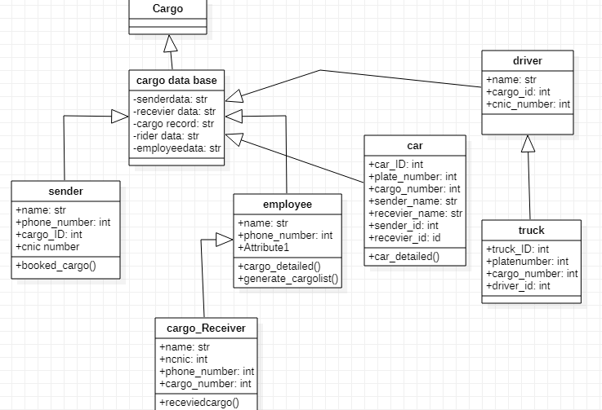

SEQUENCE DIAGRAM :

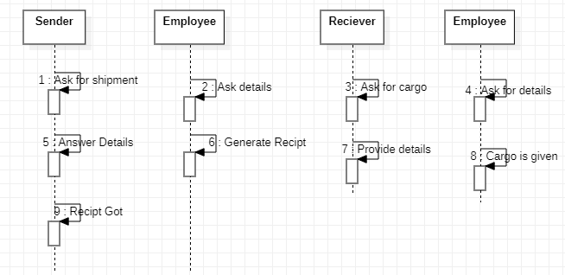

class cargo:

print("this cargomangement system")

USECASE DIAGRAM :

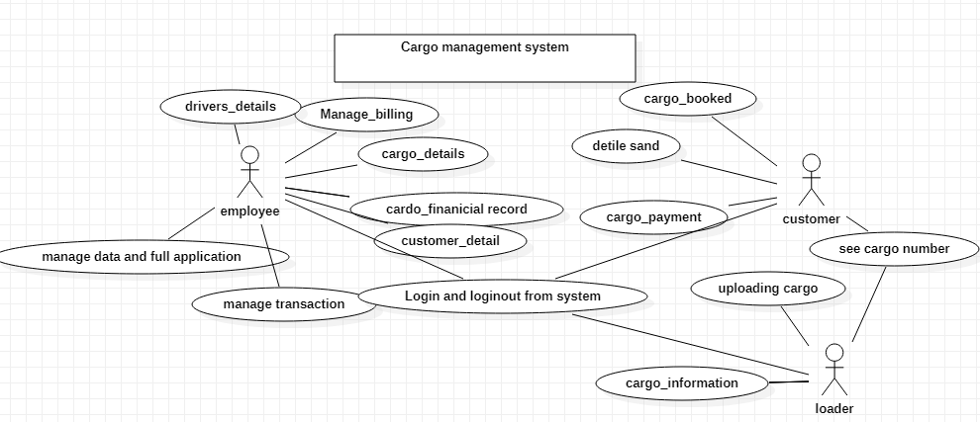

class cargo_database(cargo):

def __init__(self,sender_data,receiver_data,cargo_record,employee_data,driver_data):

self.sender_data=sender_data

self.receiver_data=receiver_data

self.cargo_record=cargo_record

self.employee_data=employee_data

self.driver_data=driver_data

def senderdetail(self):

print(self.sender_data)

def receiverdetail(self):

print(self.receiver_data)

def employeedetail(self):

print(self.employee_data)

def driverdata(self):

print(self.driver_data)

class sender(cargo_database):

def __init__(self,sender_data,receiver_data,cargo_record,employee_data,driver_data,name,phonenumber,cargo_id,cnic_number):

cargo_database .__init__(self,sender_data,receiver_data,cargo_record,employee_data,driver_data)

self.name=name

self.phonenumber=phonenumber

self.cargo_id=cargo_id

self.cnic_number=cnic_number

def booked_cargo(self):

return('The name of sender is {} his cnic is {} and his phone no is {} and his cargo_id is {}'.format(self.name,self.cnic_number,self.phonenumber,self.cargo_id))

class Employee(cargo_database):

def __init__(self,sender_data,receiver_data,cargo_record,employee_data,driver_data,name,phone_number):

cargo_database .__init__(self,sender_data,receiver_data,cargo_record,employee_data,driver_data)

self.name=name

self.phone_number=phone_number

def cargo_detailed(self):

return("The sendermail record are {} \n The recevierrecord are {}\n The cargorecord are {} and the driver data{}".format(self.sender_data,self.receiver_data,self.cargo_record, self.driver_data))

class cargo_receiver(Employee):

def __init__(self,sender_data,receiver_data,cargo_record,employee_data,driver_data,name,phone_number,Receiver_name,Receiver_phone_number,cnic_number,cargo_number):

cargo_database .__init__(self,sender_data,receiver_data,cargo_record,employee_data,driver_data)

self.Receiver_name=Receiver_name

self.Receiver_phone_number=Receiver_phone_number

self.cnic_number=cnic_number

self.cargo_number=cargo_number

def received_cargo(self):

return(self.Receiver_name,self.Receiver_phone_number,self.cnic_number,self.cargo_detailed)

receiver=cargo_receiver(["Muhammadhuzaifa\n Muhamamd Bilal \n Muhammad safi"],["muhammad saad","safi uddin"],["cars"],["zubair","asad","faraz","shoaib"],"##","Ajaz","03360213796","sohail","03158287251","2353644745885959","56321")

sen=sender(["Muhammadhuzaifa\n Muhamamd Bilal \n Muhammad safi"],["muhammad saad","safi uddin"],["cars"],["zubair","asad","faraz","shoaib"],"##","Ajaz","03360213796","456789","74278723232")

print(receiver.senderdetail())

print(receiver.receiverdetail())

print(receiver.employeedetail())

print(receiver.driverdata())

print(sen.booked_cargo())

print(receiver.cargo_detailed())

print(receiver.received_cargo())

